Introduction to Molecules Molecular Bonding and Shapes
Student’s Name
Institution’s Name

Introduction to Molecules Molecular Bonding and Shapes
Background Information
A molecule refers to a substance that composed to elements that are held together by chemical bonding. Molecule may be have one single element that is combined together a good example is the oxygen molecule or a combination of multiple elements for instance water molecule (Bemis, et.al 2016). The major chemical bondings that are involved in combining elements includes covalent, ionic, dative among others. They are few elements that exist as single atoms in nature; most of them are usually bonded to one another (Bemis, et.al 2016). Reason being the outer energy level will be fully occupied thus more stable. The atoms bond to each other through the transfer or sharing of electrons. Group 18 is only elements that exist as atoms since their outer molecules are fully occupied. The report will tend to discuss the molecular bonding through classification of bonds, drawing Lewis structures and predicting molecule geometry.
Material and equipments
25 balloons
Set of molecular model
Ruler
Calculator
Pencil
Digital camera
Cautions
Student should use the required personal protective equipment. More so, all instructions should be read careful before the experiment to be conducted. Lastly, latex balloons may cause allergic to some students.
Procedure and methods
Drawing Lewis structures of SiO₂
The number of valence electrons was determined for each atom in SiO₂ and then valance electrons of all atoms were sum up together. The central atom was then determined where the least electronegative was preferred. The chemical symbol of central atom was written followed other atoms. The dots were used accordingly to show the valence electrons around for each atom based of their position in the periodic table. Then the total number of electrons required for each atom in outer energy level was determined. The skeleton structure was created by the connecting unpaired electrons from the central to the unpaired electrons on the atom around the central atom. The structure of SiO₂ was redrawn by showing clearly bonding. The formal charge was used to determine the Lewis structure where the numbers of valence electrons were counted to each atom that is not bounded. Then lone pairs of electrons of each atom was assigned then combined to other lone pairs and then numbers of covalent bonds were counted. Assigned electrons were then subtracted from the valence electrons forming Lewis structure.
Electron Domain Geometries
Linear Geometry model was made by a balloon that was inflated and then tied the open in a knot. Then second balloon with same size was filled with air and the two balloons were tied together in knot. The model was the labeled and photo was taken. Trigonal planar geometry was also prepared by three balloons where the above procedure of linear geometry was repeated. Tetrahedral geometry was then prepared where four balloons was filled with air. Two sets of each two balloons were formed. Then the two sets of balloon were twisted together, crossing the knotted centers. Trigonal bipyramid geometry was also formed by five balloons where two sets were prepared; two balloon and three balloons. Then the two sets of balloons were twisted together by crossing the knotted centers. Lastly, octahedral geometry was prepared by six balloons, where the procedure of making trigonal bipyramid geometry was applied in formation of octahedral model.
Bonding
Bonding Pair | Electronegativity Difference | Type of Bond
Li and F | 1.0-4.0=3.0 | Ionic
F and F | 4.0-4.0=0 | Non-polar covalent
C and F | 2.4-4.0=1.5 | Polar covalent

The table was used to determine the types of bond LiF, F₂ and CF₃ exhibited. The electronegativity difference and polarity was then determined. Calculations was recorded in the table
Modeling of hydrocarbons
Covalent bond between carbon and hydrogen was formed where black was attached with four white pieces. The black piece was carbon and white piece was hydrogen. The structure was labeled methane and photo was taken. 
Propane was also made by repeating the above procedure.
Results and Discussion
- Most elements exist as components of compounds rather than in a free state. Explain why.
Most of the elements in the Free State do not have a full valence shell. In a compound, they are able to complete an octet. They cannot do this in Free State.
- Use colored pencils to lightly shade each element in the Periodic Table of Electronegativity Values.
Color 1 | Color 2 | Color 3 | Color 4
0 – 0.9 | 1.0 – 1.9 | 2.0 – 2.9 | 3.0 – 4.0

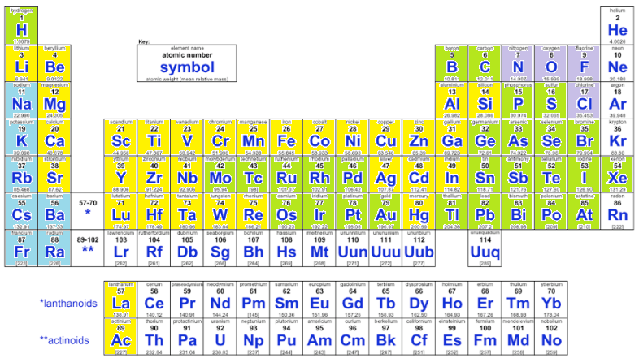

Fig: Periodic table based on electronegativity.
- How does electronegativity influence the bond character between two elements?
The polarity of the bond is determined by the electronegativity. The difference in the electronegativity will also determine if the compound is ionic or covalent. Also, it determines which atom is the central atom in the compound.
- Describe the conditions that make covalent compounds polar.
Through the unequal sharing of electrons, covalent compounds are made polar.
- List the advantages of each type of model and the information that it provides and then list the limitations of that model.
Molecular Formula
It shows the actual makeup of the compound under focus. However, it does not describe the arrangement of the atoms in the compound. They show the same formula for different isomers of a compound.
Structural Formula
It shows how the atoms in the compound are arranged. It also shows the single, double, or other nature of the bonds in the compound. They can also be used to differentiate between isomers.
Condensed Structural Formula
It is similar to structural formula but is written in a single line. It saves space, is faster and more convenient to write. However, they do not show detailed structures existing in the compound.
Skeletal Model
It shows the skeleton of a compound made up of atoms. It is more commonly used for organic compounds. It also makes use of certain symbols to indicate sub-compounds such as Benzene in a compound. It is more difficult to draw and takes longer time. Another drawback is that it assumes and does not draw certain atoms in a compound such as Hydrogen.
Ball-and-Stick Model
It is three dimensional set up of a compound. It indicates the bonds and the atoms. It makes it much easier to visualize arrangement of atoms. It is more costly and takes a lot of time to set up.
Space-Filling Model
In this model, spheres are used to indicate an atom and space between them is used to indicate bonds. Colors are also used to indicate different models. Creating this model is also costly and time-consuming.
- Both the alkene C₄H₈ and the alkyne C₄H₆ have rigid bond structures. However, C₄H₈ can form three isomers, whereas C₄H₆ can form only two isomers. Why is this so?
The alkene has a double bond connecting the carbon atoms. This leaves room for the other four hydrogen atoms to be rearranged. On the other hand, the alkyne has only two extra hydrogen atoms.
- Are these molecules isomers? Why or why not?
 |  | 

Yes, both of these are isomers because each of these symbols has four points for the attachment of atoms.
- Which of the following molecules are geometric isomers, and which are structural isomers? Which molecule is in the trans position and which is in the cis position?
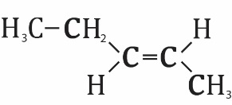 | 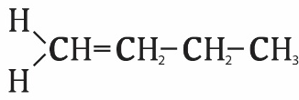 | 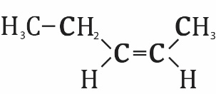

Geometric-Trans Geometric-trans
- The skeletal model of benzene is often drawn like this:
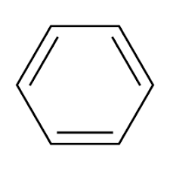
Conclusion
Ionic and covalent are main chemical bonds that are used in making compounds and molecules. Furthermore, we can conclude that most of elements exist as molecules. Also, the Lewis drawing is the best method of representing the molecular bonding. In additional, the method can use to predicting the geometry of a molecules.

Reference
Bemis, G. W., & Murcko, M. A. (2016). The properties of known drugs. 1. Molecular frameworks. Journal of medicinal chemistry, 39(15), 2887-2893.
Mezey, P. G. (2014). Shape in chemistry: an introduction to molecular shape and topology (p. 22). New York: VCH.

